# Progress report 2023-08-21

RG Wells – 22961305

# What I’ve been working on:

I have classified the step climbing movement into a set of sequential motions, such as lifting the back wheel when it encounters a step, or pulling itself up the step. I then set up an experiment to determine the stalling torque required for the device to climb during each motion. See below for a rough sketch of each motion.

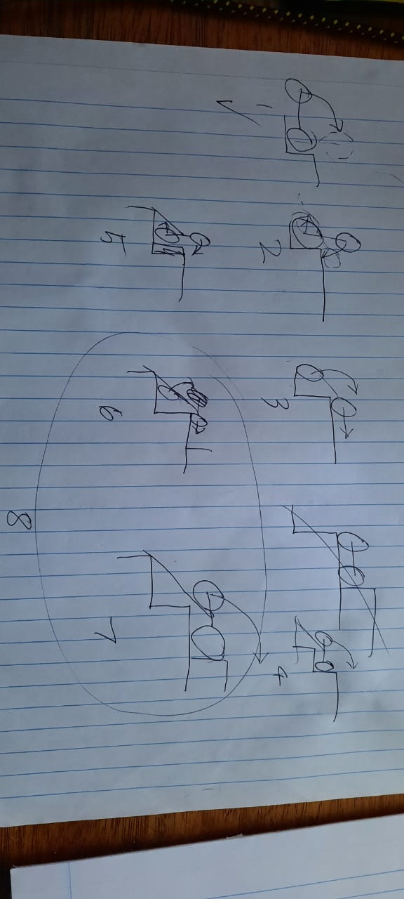

To do this, I place the device at a starting point and turn on the motor at a set voltage. I then note whether the device does not move, moves partially but does not complete the motion, or completes the motion. I repeat these steps with varied motor voltages to determine the voltage that allows the device to climb. I then calculate the stalling torque at this voltage using the relation I had determined experimentally previously. I then repeat this experiment for each motion.

For example, here is a plot of stalling torque related to whether the device climbs or not:

This experiment was repeated in the simulation to give a similar plot:

Which shows that the the simulated device requires slightly less torque to climb than the actual device.

The differences between these results allow me to quantify the error is my simulation, however there are some limitations:

* Certain motions, such as motion 2, do not require any torque to perform so cannot be validated by measuring stalling torque
* By only measuring the stalling torque, I am only validating the statics, not the dynamics.

I’ve also started reworking my mathematical model to solve a set of simulatnious equation

# What I’m working on next:

Model validation: I have identified several individual stages in the climbing motion. I will test the stalling torques required to move the device in each stage and use these to validate the math model and simulation. Some of these stages involve slipping and collision which is difficult to model mathematically, but I can test that the simulation shows similar results.

Improve models: I want to improve the structure of my math model so that it is easier to use and consider different loading scenarios. I will likely identify shortcomings in the model in the validation stage, and have to update it to match the mechanics of the physical device.

-----------------------------------------------------------------------------------------------------------------

Unchanged:

Next iteration: While building and testing the device I have been considering potential improvements for a future version. If time allows, I would like to build a second device after I have validated the model using the first device. The design of this device would consider lessons learned from the model, and multiple concepts could be quickly tested in simulation. The ideas I’m currently pondering include using bearings, herringbone gears, brushless dc motors, and possibly even connecting the two LIMs together with a bolt so they move rigidly together, eliminating the possibility that one moves ahead of the other.